**OOP Assignment –2**

**Areej Abrar**

**SP24-BSE-141**

**Section : B**

**MessagingApp – - - 2 Way Communication by Socket using**

**There are 6 classes**

1. Contact Class–(name,phone number)
2. Msg Class–(All attributes)
3. Server Class
4. Client Class
5. MessagingApp Class–(All Functions for handling all the operations)
6. MessageDriver Class–(menu)

**Exploring the App**

* There are 8 Functions in the app

We will focus on the Option 4 - - > 2 Way Communication (PC to PC ) by using **IP address**

**Based on Server - Client Relationship**

First we have to add Contacts from whom we want to do communication …..

**Working - - Output :**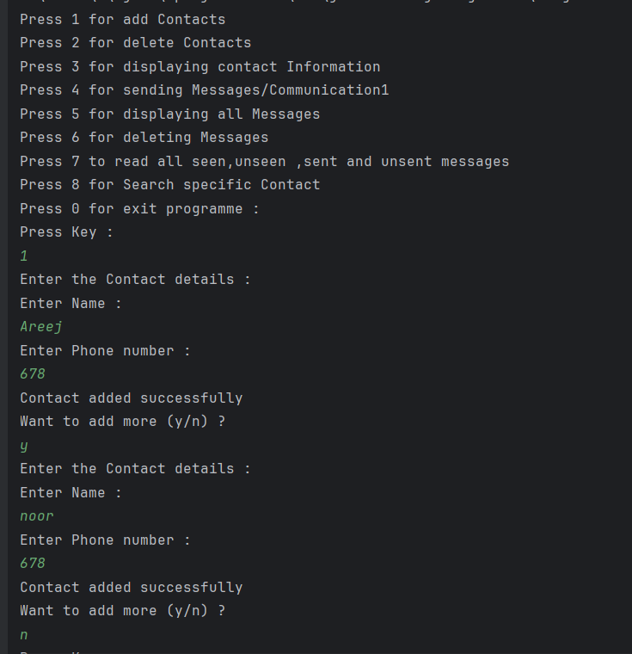

After adding the contacts now we will do the communication :

In Communication There r 2 options :

1 )2 Way Communication

2)Simple Messages

First we will see the Communication ;

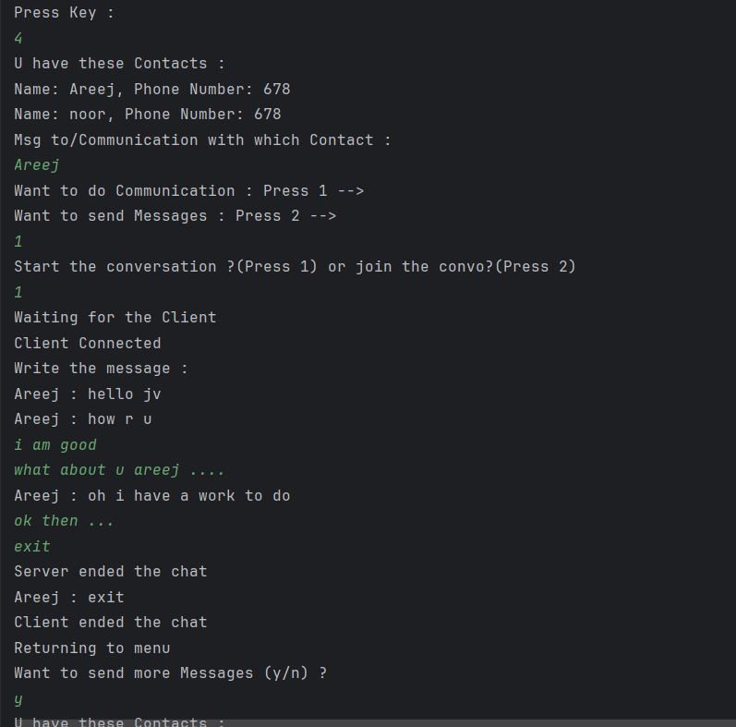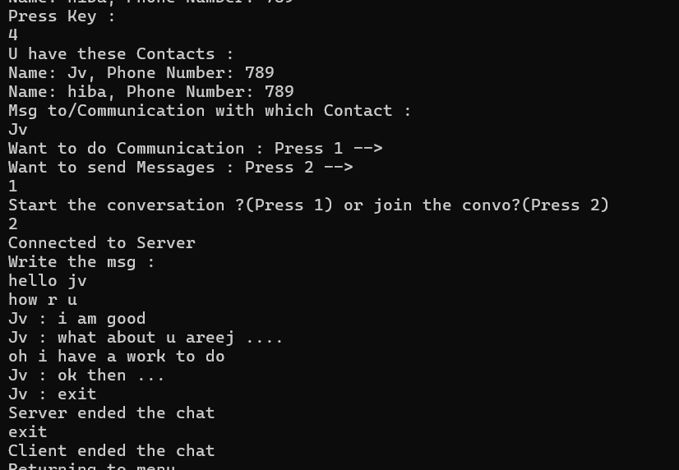

**Some Important Points of Conversation :**

1. One will act as Server and other will act as a Client but code is made like this that both Server and Client can Messages to each other…
2. One can act as Client or Servent which he/she want
3. The chat will end when server and client will write “exit”
4. These all messages are stored (msgs by the client and server )
5. Threads are also used by implementing Runnable Interface for processing multitask Operations….as by using threads One person can res=cieve messages and send messages at a time.

**Some important Code used in the Server- Client Classes :**

try (ServerSocket ss = new ServerSocket(6666);)

Socket s = ss.accept();

DataInputStream d = new DataInputStream(s.getInputStream());

DataOutputStream dout = new DataOutputStream(s.getOutputStream());

dout.writeUTF(msg);

str = (String) d.readUTF();

Thread s_thread = new Thread(new Runnable() {

@Override

public void run() {

send_msg(sc,dout);

}

});

**2) Simple Messages**

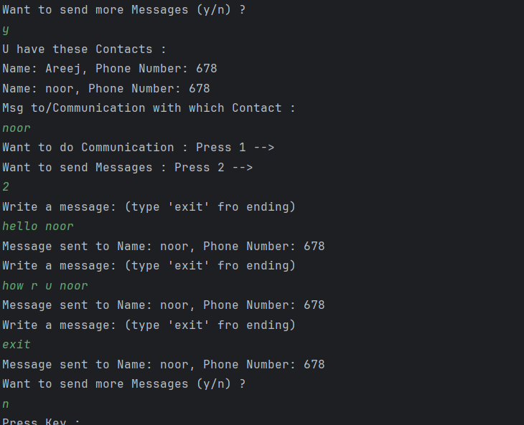

Simple msgs are also stored

**Displaying Msgs:**

Server ,Client ,simple Messages all are stored and hence displayed ….

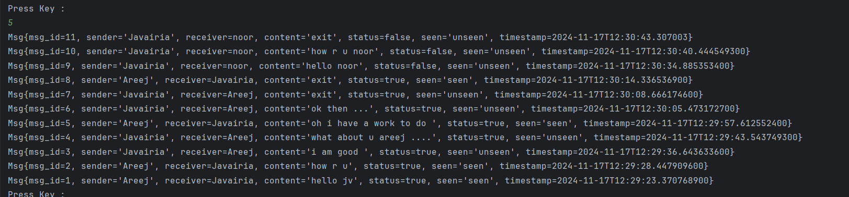

Display Msgs of Specific Contact :

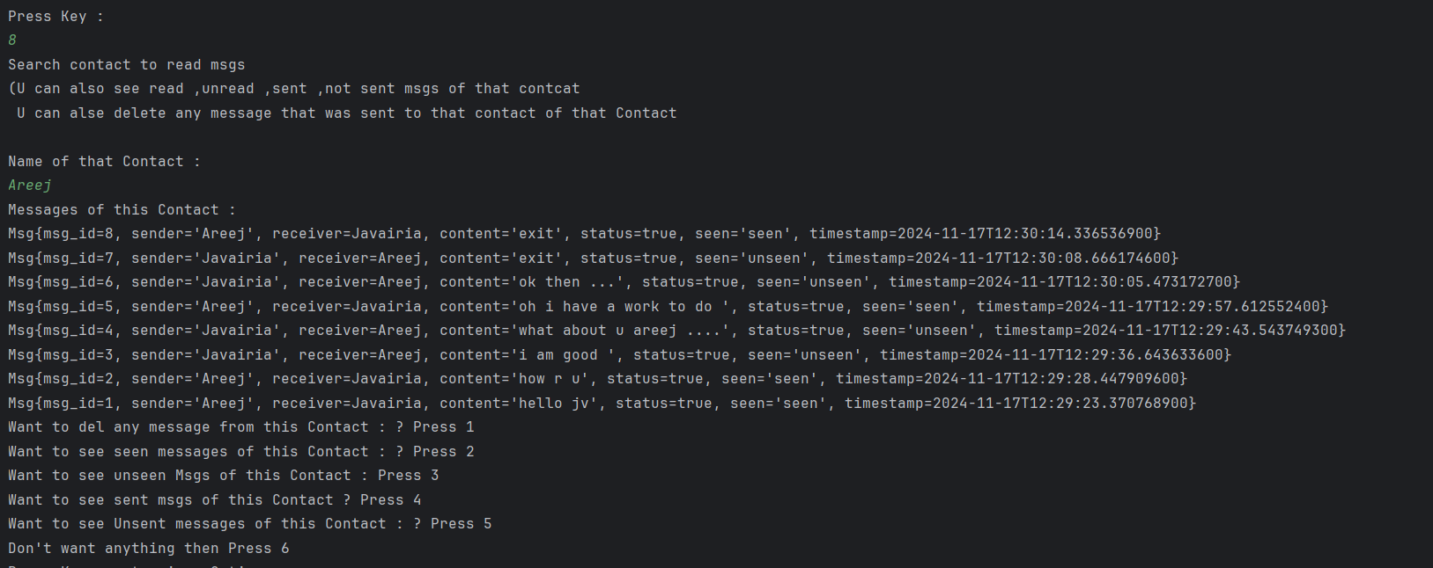

As The messages which Areej sent to me and msgs which I sent to Areej only those messages are displayed and we can do all the operation on these messages which shown in this image.

**Note : I have showed the specific Output not all As the main purpose of this assignment just to show the 2 way communication….**